GAC stands for Global assembly cache and strongly named assembly are only present on GAC. Assemblies in the GAC can be shared by all applications running on that machine, without having to copy the assembly locally.

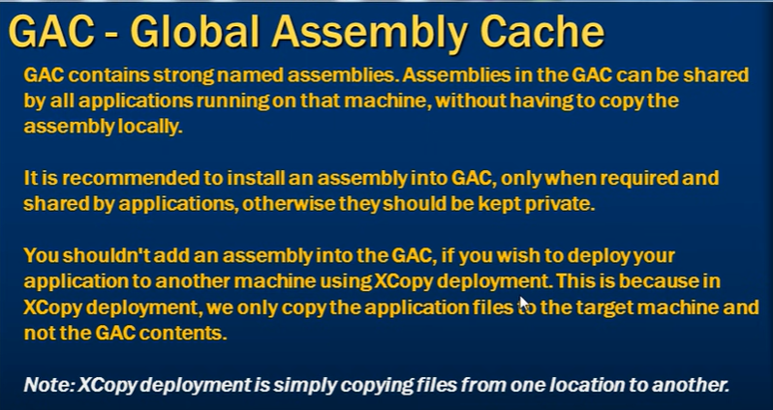

When we add a dll to a project file as a reference, a copy of dll get copied to bin folder of the main project file. This can be turned off and on under property of add dll or assembly.

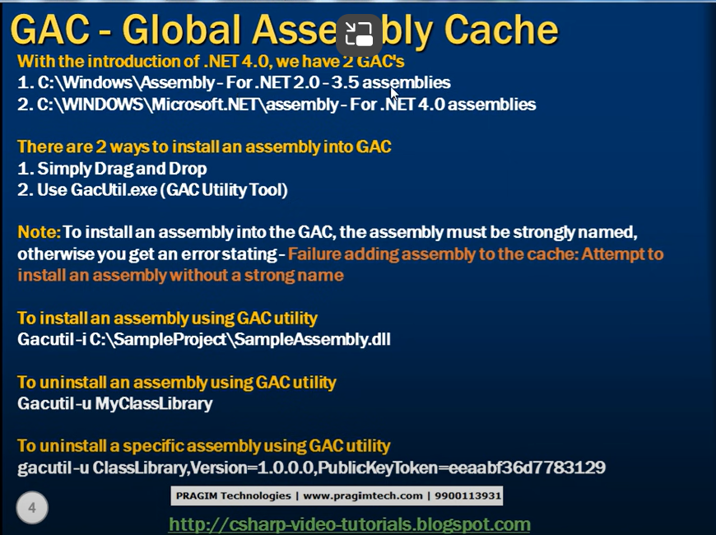

**side by side execution**

Assemblies with same name, same public key token live in the same folder with different version is called as side by side execution in .Net